

*shell programming lab*

aSsignment -13

**SUBMITTED BY: SUBMITTED TO:**

**AYUSH KUMAR JHA Dr. Dhiviya Rose**

**SAP ID - 500086400**

**Enrollment no - R200220083**

**B.C.A -I.O.T.**

1. Change the permission set of /work/readme.txt so that only the user (owner) can read,write, and execute it. Use absolute mode.

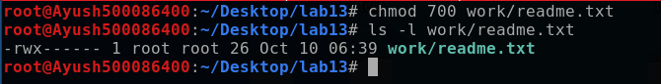

1. Change the permission set of /work/readme.txt so that any user can read it, the group can read/write to it and the user (owner) can read/write/execute it. Use absolute mode.

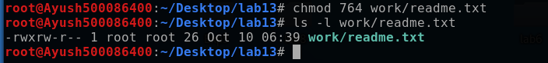

1. Change the permission set of /bin/bash so that only the user (owner) can read/write/ execute, group, and any user can execute it. However, whenever anyone executes it, it should run with the privileges of the owner user. Use absolute mode.

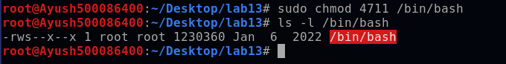

1. Change the permission set of /work/readme.txt so that only the user (owner) can read, write, and execute it. Use symbolic mode.

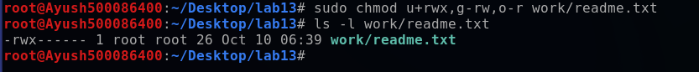

1. Change the permission set of /work/readme.txt so that any user can read it, the group can read/write to it and the user (owner) can read/write/execute it. Use symbolic mode.

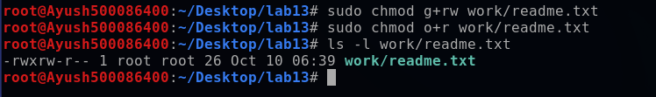

1. Change the permission set of /work/readme.txt so that only the user (owner) can read/write/ execute, group, and any user can execute it. However, whenever anyone executes it, it should run with the privileges of the group. Use absolute mode.

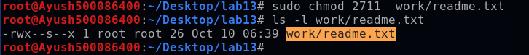

1. Change the permission set of /work/readme.txt so that only the owner can rename or delete this file while maintaining the existing permissions. Use absolute mode.

